**DESIGN DIAGRAMS:**

**1.USE CASE DIAGRAMS:**

**Use case diagram for entire online library management system:**

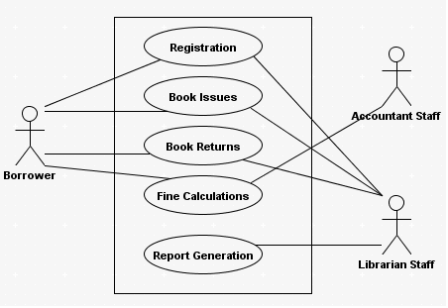

**Use case diagram for issues:**

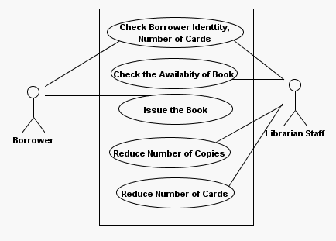

**Use case diagram for returns:**

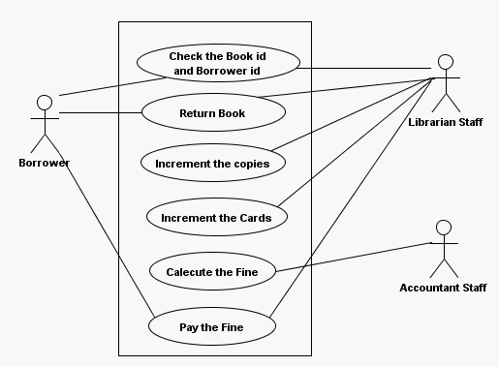

**2.INTERACTION DIAGRAMS**

**2.1 SEQUENCE DIAGRAMS:**

A sequence diagram shows an interaction in a time sequence. It shows the objects participating in the interaction by their life lines and messages they exchanged and arranged in a time sequence.

**Sequence diagram for Online Library Management System :**

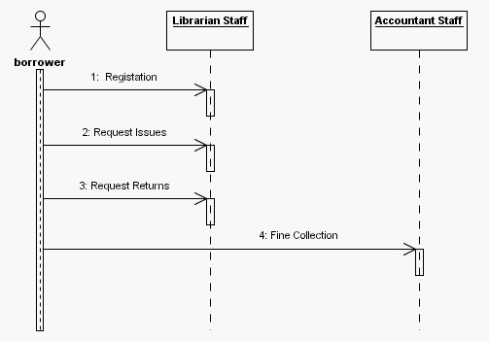

**Sequence diagram for book issue:**

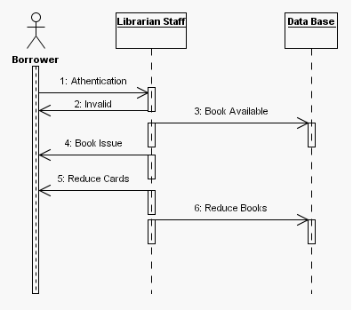

**Sequence diagram for book returns:**

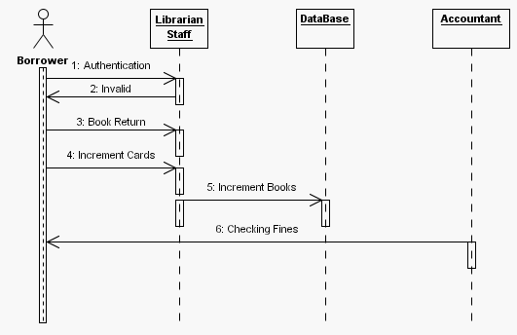

**Sequence diagram for fine:**

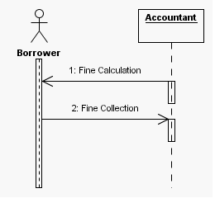

**2.2 COLLABORATION DIAGRAM:**

**Collaboration diagram for Online Library Management System:**

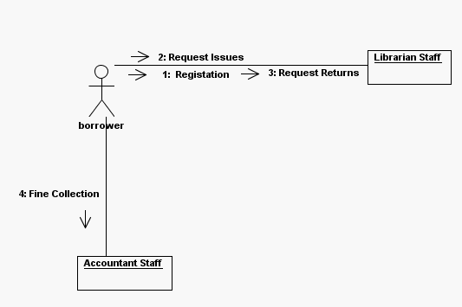

**Collaboration diagram for book issue:**

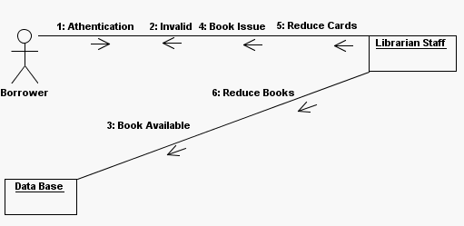

**Collaboration diagram for book returns:**

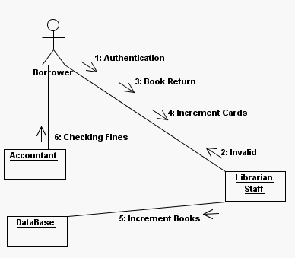

**Collaboration diagram for fine:**

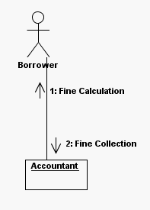

**2.3 STATE CHART DIAGRAMS:**

State diagrams explain different states in the system in a more descriptive manner. This chart deals with different states.

**Complete state diagram for Online Library Management System:**

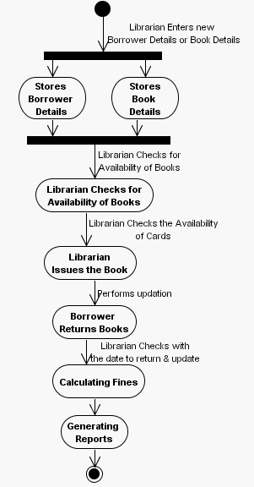

**State diagram for issueing a book:**

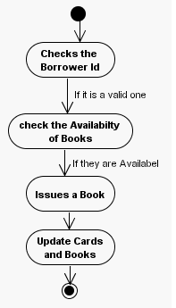

**State diagram for returning a book:**

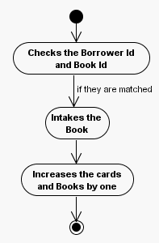

**2.4 ACTIVITY DIAGRAMS:**

An activity diagram shows the behavior of the system in terms of activities. Activities are the elements to represent the execution of set of operations.

**Activity diagram for Online Library Management System:**

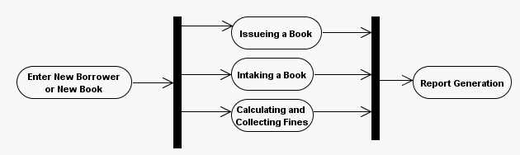

**Activity diagram for issuing activity:**



**Activity diagram for intaking a book:**



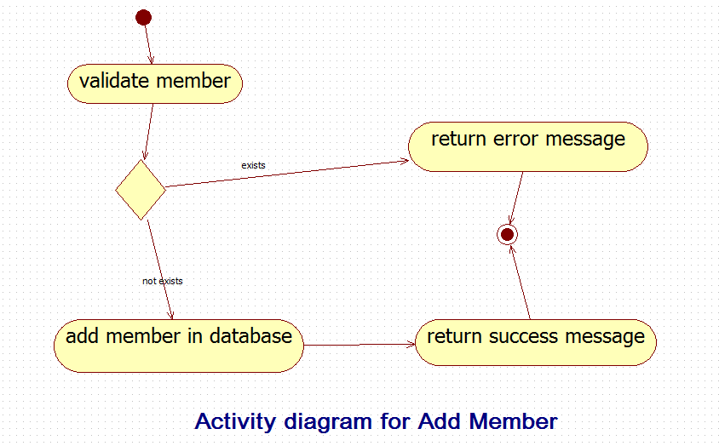

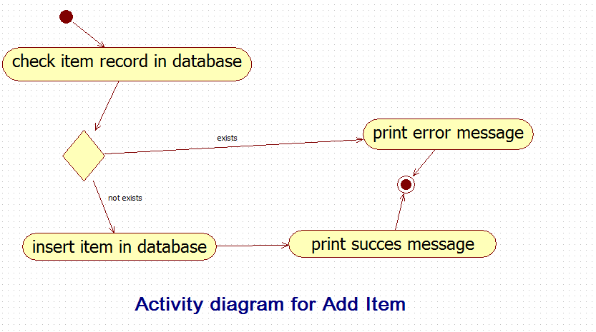

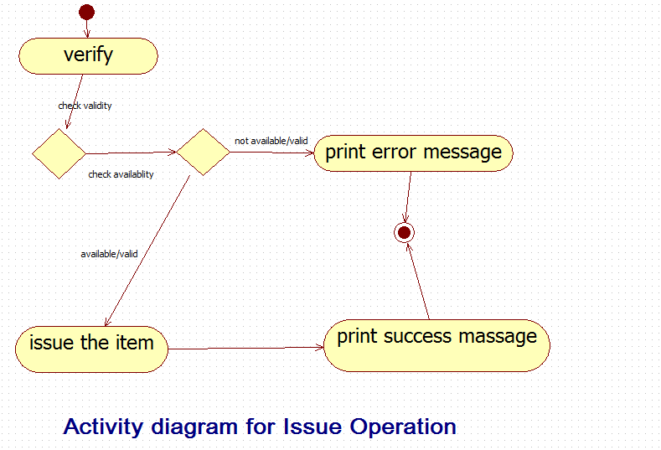

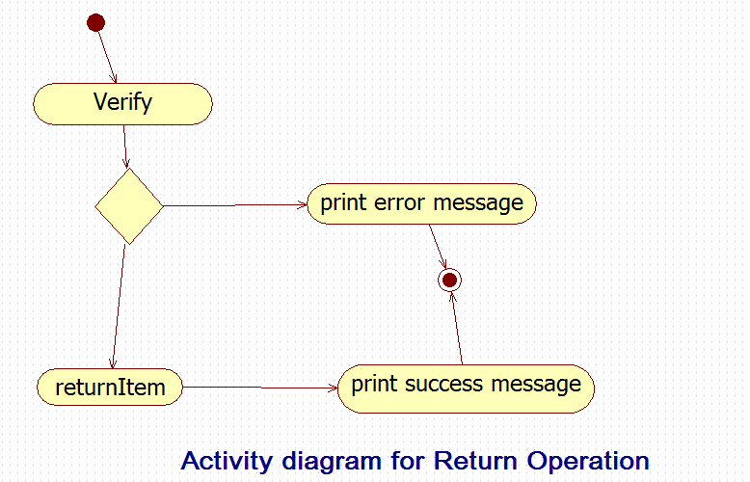

**3. System Architecture:**

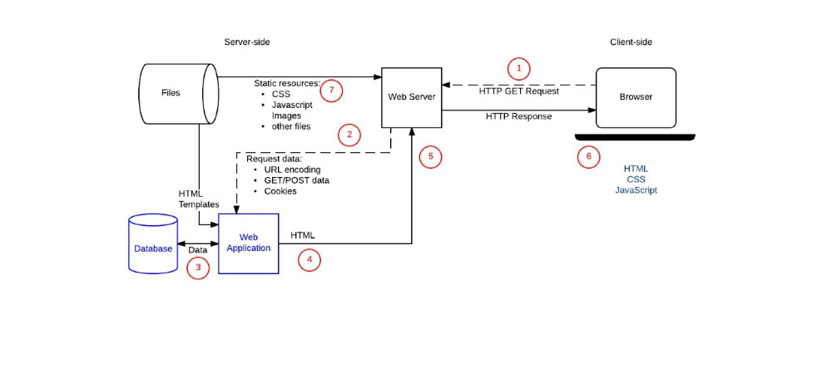

**4. ER DIAGRAM:**

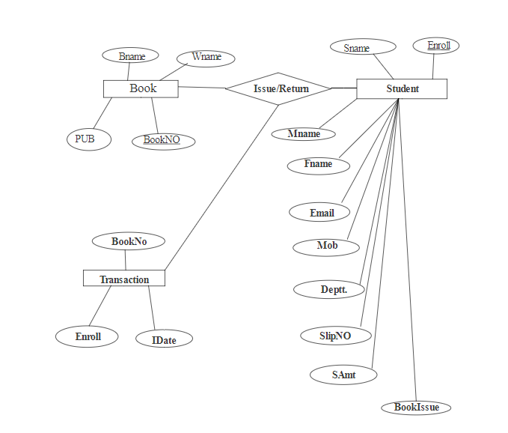

**4. Data Flow Diagram:**

